**Project Proposal**

Hyper-realistic BEAR SIMULATOR.

Interact with Bear the bear! Endless fun will be had.

The user acts on Bear by giving text input. Bear shows a change in emotional state, and his reaction is conveyed through ASCII characters and a brief prompt. (Bear is slightly pretentious and takes offense easily.)

The simulation ends when either the user or Bear kills himself.

HAVE FUN!!!

Bear’s avatar is an array of ASCII characters:

|  |  |  |
| --- | --- | --- |
| (￣(エ)￣) | (｡･ω･｡) | (●｀･(ｴ)･´●) |
| (*ノ・ω・） | 川´･ω･`川 | ( (ﾐ´ω`ﾐ)) |
| ヾ(T(エ)Tヽ) | ＼(・｀(ｪ)・)/ | ⊂(ο･㉨･ο）⊃ |
| (^(エ)^) | (^(I)^) | (￣(ｴ)￣)ﾉ |
| ⊂(￣(工)￣)⊃ | ⊂(^(工)^)⊃ | ⊂(・(ェ)・)⊃ |
| (*￣(ｴ)￣*) | ヾ(´(ｴ)｀ﾉﾞ | (／(ｴ)＼) |
| ⊂(￣(ｴ)￣)⊃ | “(`(エ)´)ノ | (｀(エ)´)ﾉ |
| (ó㉨ò) | (♥ó㉨ò)ﾉ♡ | (/-(ｴ)-＼) |
| (´(エ)｀) | ヽ(￣(ｴ)￣)ﾉ | (／￣(ｴ)￣)／ |
| ⊂(◎(工)◎)⊃ | (●￣(ｴ)￣●) | 《/(￣(ｴ)￣)ゞ》 |
| ⁝⁞⁝⁞ʕु•̫͡•ʔु☂⁝⁞⁝⁝ | (✪㉨✪) | ᶘ ᵒᴥᵒᶅ |

- See more at: <http://hexascii.com/bear-emoticons/#sthash.t4G41GcR.dpuf>

**Bear has basic emotional states:**

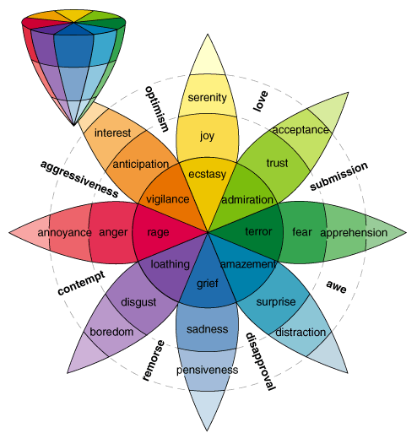

3 categories:

|  |  |  |  |
| --- | --- | --- | --- |
| Value | Happiness | Anger | Sadness |
| 0 | Neutral | Neutral | Neutral |
| 1 | Satisfied | Annoyed | Solemn |
| 2 | Happy | Highly Irritated | Sad |
| 3 | Ecstatic | Angry | Depressed |
| 4 | Absolutely beartastic | Bearzerk | Suicidal |

There is another category: Hunger. The hungrier bear is, the angrier he gets. (Hunger ranges 0-5.)

Emotion rules:

* If you add to happiness, you need to take away from anger and sadness.
* Adding to anger takes away from happiness, but not sadness.
* Sadness takes away from happiness, but not anger.
* If Bear is angry for long enough, he becomes sad.
* Bear has highs and lows.
* If Bear is really happy (a high), he will inevitably crash and have a low.

**Interaction with Bear:**

Your actions affect Bear’s emotional states. Actions have both immediate and long-term effects.

Bear has immediate reactions to your actions.

|  |  |  |
| --- | --- | --- |
| Actions | Bear’s reaction | Reaction text (more dynamic than just ‘angry,’ ‘sad’ – specialized) |
| Insult | Anger increases; | ‘bear is insulted.’  ‘why do you keep insulting bear?!’  ‘YOUR INSOLENCE IS UNFORGIVEABLE!’ |
| Complement | Happiness increases; | ‘oh, why, how kind of you.’  ‘really, you are too kind.’  ‘bear is absolutely BEARTASTIC!’ |
| Feed | Anger decreases; Happiness increases | Stuff like the above. |
| Hit | Anger increases automatically to angry |  |
| Pet | Anger increases if already angry; If not angry, happiness increases |  |
| Tell a joke | Possibilities: be too serious and take offense – anger increases, happiness decreases; get your joke – happiness increases, anger decreases; think your joke is terrible – happiness to zero, anger to slightly irritated  (which jokes are funny? Parse for certain words (e.g. ‘knock knock’ or ‘fart’) | ‘bear does not find knock-knock jokes funny.’  ‘HAR HAR! Bear loves fart jokes.’ |
| Be sarcastic | anger up – this is a very serious bear. | ‘Bear is confused. What?!’ |
| Threaten | Bear automatically angry or higher | ‘YOU DARE THREATEN BARE?! INSOLENT WORM!’ |
| Apologize | If angry, makes bear angrier – your apology is fake; less irritated or less, bear begrudgingly accepts – lowers anger. | ‘Bear grudgingly accepts your apology.’  ‘Filthy hu-man! Bear KNOWS you are not truly sorry! Do you take Bear for a fool?’ |

**Interface:**

Bear

Happy: 0 Sad: 0 Angry: 0

-----------

(￣(エ)￣)

-----------

Bear is ‘neutral.’

What would you like to do to Bear?

>> THREATEN HIM!!!

-----clear screen--------

Bear

Happy: 0 Sad: 0 Angry: 5

-----------

⊂(◎(工)◎)⊃

-----------

YOU DARE THREATEN BARE?! INSOLENT WORM! || Bear is ‘angry.’

What would you like to do to Bear?

>> …

**GUI**

Classes

Image class (BackgroundPanel)

Health bar

Hunger bar

Dialogue box

Model-view-controller

Text input box

Text output box